Project Design Phase
Solution Architecture

Date | 09 February 2026
Team ID | LTVIP2026TMIDS85199
Project Name | AutoSage App Using Gemini Flash
Maximum Marks | 4 Marks

Solution Architecture – AutoSage App
The solution architecture of AutoSage defines how the system converts raw vehicle images into meaningful, structured insights using AI. It outlines the interaction between the user interface, application logic, and the AI model to ensure smooth data flow, accuracy, and scalability.
The architecture is designed with the following objectives:
- To enable users to upload vehicle images through a simple and intuitive web interface.
- To process and validate images efficiently before analysis.
- To leverage an advanced AI model for extracting vehicle-related information.
- To deliver structured results such as vehicle brand, model, mileage, estimated price, and condition.
- To support reliable deployment and easy system maintenance.

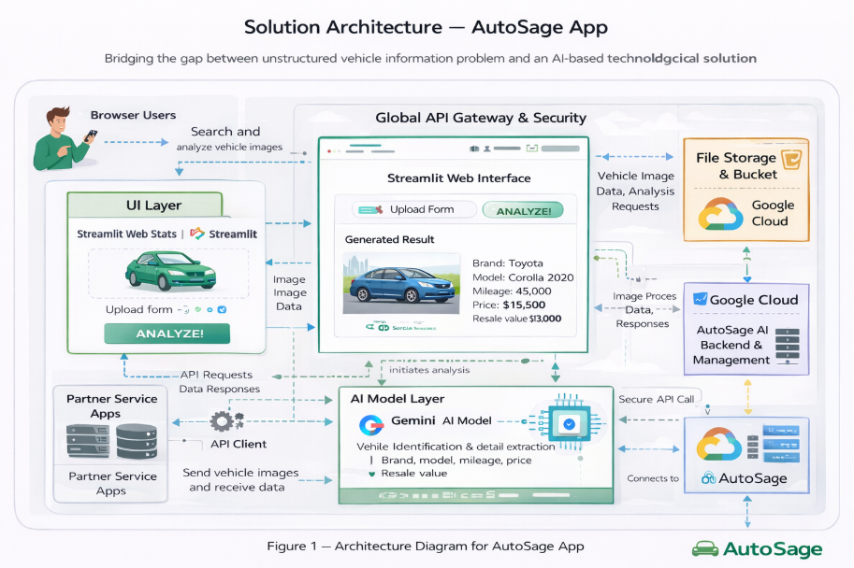
Solution Architecture Diagram:

